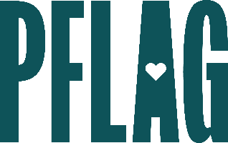
Below is starter language for your learning session invitation. Feel free to personalize as needed to make it engaging for your audience! Need logos? Check out PFLAG’s brand guide and access logo downloads online.
I’m Not LGBTQ+…Not That There’s Anything Wrong with That: Advanced Ally Skills
Even the most well-intentioned and dedicated allies have questions about how to build inclusion at work and in their personal lives. Managing conflict continues to be a significant barrier that leaves them feeling less visible and vocal than they want to be.
In this session, you’ll learn how to grow your ally skills, no matter how you identify, on your journey to super-ally status. Sponsored by [ERG/ORG] and presented by Straight for Equality (a program of PFLAG National), during this learning session, you’ll have a chance to:
- Understand more about PFLAG’s Straight for Equality program and ways to recognize the ally potential in everyone;
- Take a look at the power that vocal and visible allies have already had in creating meaningful change in the United States;
- Discuss common challenges that many allies face AND learn strategies to overcome them; and
- Find out more about the resources available at [ORGANIZATION] that will help you be a more powerful ally for LGBTQ+ equality.
Event Details:
Date + Time
Location
Contact Person
Additional information (e.g. lunch is provided, please RSVP, etc.)

