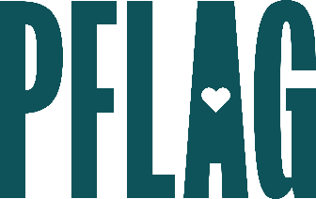 | I’m Not LGBTQ+…Not That There’s Anything Wrong with That: Advanced Ally Skills

Session Description:
Self-identified allies often find themselves faced with challenges to expressing support for the LGBTQ+ community. This may leave them less likely to speak up. In this session, participants will find out how to transform the reason they’re an ally (or need one) into their case for inclusion, get effective strategies to create conversation about LGBTQ+ equality, and understand how to transform conflict into opportunity.

Starter questions:
- Can you give an example of how you’d create a conversation about LGBTQ+ equality with a group people?
- In your opinion, would a cishet ally sharing their pronouns and using words like partner and spouse ever be considered appropriation?
- You mentioned assuming non-harmful intent – do you have any recommendations for those times you really, truly believe someone’s intent is to be harmful?

