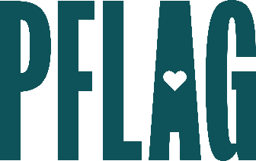 | Advanced Bi+ Allyship: Going Beyond  the “Bi”nary

Session Description:
Beginning the ally journey can take a lot of introspection about (un)conscious biases—and that work must continue to become a more advanced ally. Participants in this session will learn more about common myths and stereotypes about people who are bisexual+ discuss advanced bi+ ally behaviors, and continue the conversation about how organizations can grow to be even more inclusive of colleagues who are bi+.

Starter questions:
- Where do you think the most common myths about bi+ people come from?
- Are there any examples of popular media right now that you think are really doing bi+ representation well?
- Do you have any recommendations for conversations with people who assert that identifying as bisexual is trans exclusionary?

