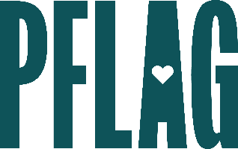
Below is starter language for your learning session invitation. Feel free to personalize as needed to make it engaging for your audience! Need logos? Check out PFLAG’s brand guide and access logo downloads online.
Want to Be an Ally (Or Help One Out?): Building the Path for Your Ally Journey
Roughly half of people who identify as LGBTQ+ are still in the closet at work. For companies that would like to demonstrate their commitment to diversity, equity, and inclusion having visible, vocal, and engaged allies is at the heart of the solution. But becoming an engaged and active ally isn’t always easy.
You’re invited to learn more about who allies are, why they’re needed, and how you can become (or help others become) an ally that is ready to take action. Sponsored by [ERG/ORG NAME] and presented by Straight for Equality (a program of PFLAG National) you’ll have a chance to:
- Quickly review and understand more about LGBTQ+ terminology (and how language evolves over time);
- Learn about what the ally journey looks like and the common characteristics that allies have;
- Examine some of the changes we’ve seen when it comes to LGBTQ+ acceptance in the workplace and how the current political climate is impacting LGBTQ+ employees worldwide;
- Talk about the barriers that allies often encounter when it comes to being visible and vocal at work; and
- Learn about straightforward, everyday actions that can help you overcome those barriers, express support, and create change in the workplace.
All participants will receive access to the guide to being a straight ally as a great takeaway resource!
Event Details:
Date + Time
Location
Contact Person
Additional information (e.g. lunch is provided, please RSVP, etc.)

