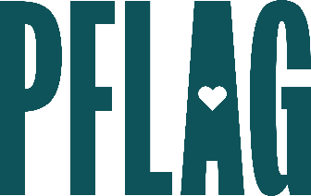 | Bi+ 101 Allyship: How to Not Let Things Fall Bi the Wayside

Session Description:
There is still an unfortunate lack of representation and understanding of the bisexual+ community in the workplace. Statistics show that over 50% of the LGBTQ+ community identifies as bisexual+, including identities such as pansexual, fluid, omnisexual, queer, and more. Participants in this session will learn more about the bisexual+ community, why it’s so important to understand and respect bi+ people, and some tools to be a great bi+ ally.

Starter questions:
- Why do you think people who are bi+ are out at such significantly lower rates than gay and lesbian folks?
- It seems like a lot of young people identify as bisexual+. Could it be that they’re just trying to fit in or be trendy?
- Can you give some examples of what biphobia might look like in day-to-day life? What about bi erasure?

