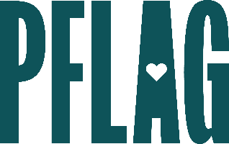
Below is starter language for your learning session invitation. Feel free to personalize as needed to make it engaging for your audience! Need logos? Check out PFLAG’s brand guide and access logo downloads online.
Becoming a Trans Ally to Go Beyond the Binary: What Would You Do?
Visibility for people who are transgender and nonbinary has increased dramatically in the US in recent years. But what we see on the news and in popular entertainment doesn’t always provide the background and context we need to understand what gender identity and expression really mean, what people who are trans and nonbinary experience, why personal pronouns matter, or what role allies can play.
[ERG/ORG NAME] and Straight for Equality (a program of PFLAG National) are here to help! Join us for an engaging learning session where you’ll have an opportunity to:
- Review LGBTQ+ terminology related to sexual orientation, gender identity and expression – including words to avoid;
- Discuss a variety of gender-expansive pronouns that you may encounter in the workplace, why they’re important, how to use them, and what to do if you’ve made a mistake;
- Examine current research to identify some of the common challenges faced by people who are transgender and nonbinary inside and outside of the workplace; and
- Consider your role as an ally and a variety of ways that you can demonstrate your allyship to folks who are transgender and/or nonbinary as well as resources to help you learn more.
All participants will receive access to the guide to being a trans ally as a takeaway resource!
Event Details:
Date + Time
Location
Contact Person
Additional information (e.g. lunch is provided, please RSVP, etc.)

