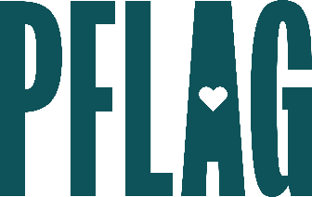 | Becoming a Trans Ally  to Go Beyond the Binary

Session Description:
People who are transgender (trans), including people who are nonbinary, report higher rates of discrimination at work than gay and lesbian individuals. This learning session applies the unique Straight for Equality approach to invite, educate, and engage allies for people who are trans and/or nonbinary. Participants will learn about key terminology related to gender identity and expression, expansive pronouns and how to use them, and skills they need to be allies to people who are trans.

Starter questions:
- Do you have any thoughts on gendered colloquialisms like “you guys” and “dude” – do you have any alternatives that you would suggest when addressing a group?
- Where I live – using sir and ma’am is expected and a way to demonstrate respect. Is there an accepted gender inclusive alternative? What would you recommend if I’m not sure how someone identifies?
- What can I do to be a better advocate for transgender youth in my state?
- I keep seeing reports that more young people than ever now identify as trans or nonbinary. What’s going on with that?

