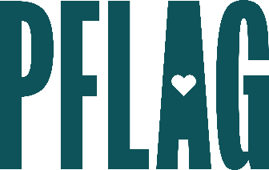 | Becoming a Trans Ally to Go Beyond the Binary: What Would You Do?

Session Description:
People who are transgender (trans), including people who are nonbinary, report higher rates of discrimination at work than gay and lesbian individuals. This learning session applies the unique Straight for Equality approach to invite, educate, and engage allies for people who are trans and/or nonbinary. Participants will learn about key terminology related to gender identity and expression, expansive pronouns and how to use them, skills they need to be allies to people who are trans, and includes opportunities for participants to navigate real-world scenarios as allies.

Starter questions:
- What should you do if you think a young person in your life might be struggling with their gender? Is it ever appropriate to ask them what’s going on?
- Someone I work with keeps making mistakes with one of our teammates pronouns and I can’t tell if it is intentional/malicious or just an honest mistake. How can I tell? What should I do?
- What can I do to be a better advocate for transgender youth in my state?

