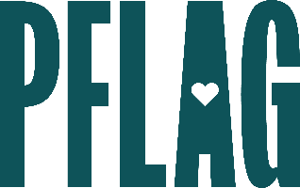
Below is starter language for your learning session invitation. Feel free to personalize as needed to make it engaging for your audience! Need logos? Check out PFLAG’s brand guide and access logo downloads online.
What Would You Do? The Advanced Ally’s Guide to Being Active in Tough Situations
Knowing when, where, and how to react to anti-LGBTQ sentiments can be stressful, especially in the workplace. This session, developed for advanced, self-identified allies, takes on that issue and leads participants in a skill-building experience to fine-tune their ally skills and develop the resources to take on a tough and tricky world.
Join [ERG NAME/ORG] for an engaging learning session with educators from Straight for Equality (a program of PFLAG National). During the session, you’ll have an opportunity to:
- Consider the steps to learn and grow that more advanced allies take to become better advocates for LGBTQ+ equality;
- Develop skills to turn potential conflict into communication and understanding;
- Apply what you’ve learned to real-world, workplace focused scenarios and share your unique strategies as part of a group discussion; and
- Access resources, materials, recommendations, and more to help with your ally efforts.
Event Details:
Date + Time
Location
Contact Person
Additional information (e.g. lunch is provided, please RSVP, etc.)

