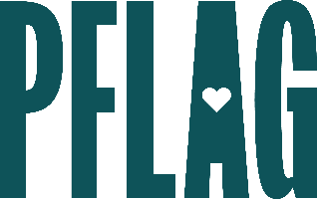
Below is starter language for your learning session invitation. Feel free to personalize as needed to make it engaging for your audience! Need logos? Check out PFLAG’s brand guide and access logo downloads online.
From the Classroom to the Boardroom: Addressing Bullying Behaviors
The devastating impact of bullying in schools has led to widespread public response, local and state level legislation, and preventative programs. But an important question still needs to be addressed: What happens when people who exhibit bullying behaviors at school enter the workplace?
You’re invited to participate in a conversation about intimidating and exclusionary behavior in the workplace, how it can impact employees who are LGBTQ+, and what allies can do about it. Sponsored by [ERG/ORG NAME] and presented by Straight for Equality (a program of PFLAG National) you’ll have a chance to:
- Discuss the similarities—and differences—between schoolyard bullying and a workplace culture that is unwelcoming and exclusionary, with emphasis on the LGBTQ+ community;
- Discover strategies that we can adapt from bullying prevention programs in schools to address similar issues in the workplace;
- Identify ways to mentor and provide support for employees experiencing exclusion at work and intervene when an employee is behaving in a way that is not inclusive; and
- Learn about various institutional changes and student led activities in schools and the ways employee resource groups can create programs that learn from what really works.

Event Details:
Date + Time
Location
Contact Person
Additional information (e.g. lunch is provided, please RSVP, etc.)

