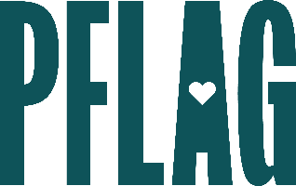
Below is starter language for your learning session invitation. Feel free to personalize as needed to make it engaging for your audience! Need logos? Check out PFLAG’s brand guide and access logo downloads online.
Cultivating Respect: Stopping Bullying to Create Safer Schools
Bullying in schools takes many forms and has lasting impact on students’ mental health, sense of well-being, and achievement. Research consistently demonstrates that anti-LGBTQ+ bullying is pervasive and under-reported and that adults are not able to intervene effectively for a variety of reasons.
You’re invited to participate in a learning session about bullying and harassment in schools and to learn what you as a parent, caregiver, and/or adult member of your community can do about it. Sponsored by [ERG/ORG NAME} and presented by Straight for Equality (a program of PFLAG National) you’ll have a chance to:
- Review recent examples of bullying and harassment in U.S. schools and discuss the profound impact anti-LGBTQ+ bias can have on all young people;
- Understand more about six key facts and related data about bullying and harassment in schools;
- Learn just a few of the many ways you can identify when a young person is being bullied or acting like a bully and what to do about it; and
- Get various ways to take action – when you’re ready – at the local, state, and federal level to help create safer schools.
All participants will receive access to Cultivating Respect: How to Make Schools Safer for ALL!

Event Details:
Date + Time
Location
Contact Person
Additional information (e.g. lunch is provided, please RSVP, etc.)

