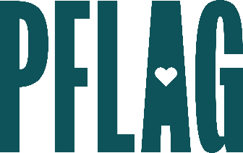 | Cultivating Respect: Stopping Bullying to Create Safer Schools

Session Description:
For many years, news reports have been filled with the tragic stories of young people being bullied and harassed in schools, and the terrible consequences many of them face when no one willingly speaks up. In this learning session, participants will learn about key research on bullying, cyberbullying, and harassment and discover accessible and tangible ways to be a part of the solution on personal, family, and institutional levels.

Starter questions:
- It seems like this effort to ban books came out of nowhere – what is going on with that and how can I advocate to keep inclusive titles on the shelf?
- If a young person lets me know that they’re being bullied – how do I reconcile respecting what they’d like to have happen (e.g., not tell anyone or make a big deal about it) and the need to do something about it to keep them safe?
- What should I do if bullying and harassment has been reported to the school/district and nothing is being done about it?

