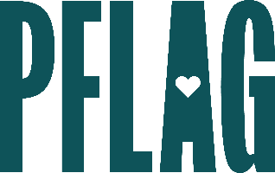
Below is starter language for your learning session invitation. Feel free to personalize as needed to make it engaging for your audience! Need logos? Check out PFLAG’s brand guide and access logo downloads online.
Employee Resource Groups Give Back: Engaging Leaders and Activating Volunteers
Understanding what motivates folks to volunteer can go a long way in developing leadership opportunities and community events that keep ERG members coming back.
Network group leaders and advocates are invited to participate in a dialogue about how they can identify and support new leaders, engage new members in events and activities, and create community impact. Sponsored by [ERG/ORG] and presented by Straight for Equality (a program of PFLAG National), during this learning session, you’ll have a chance to:
- Look at the role of leadership and how better practices can help to make volunteer roles more appealing to new members;
- Examine how we talk about volunteering and the impact that has on engaging new participants;
- Talk about how thriving ERGs can build volunteer opportunities that demonstrate community impact – and why that is important; and
- Get tools and resources to help with your work!

Event Details:
Date + Time
Location
Contact Person
Additional information (e.g. lunch is provided, please RSVP, etc.)

