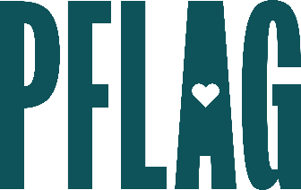 | Don’t Know Much About LGBTQ+ History? The Ultimate LGBTQ+ History and Culture Extravaganza

Session Description:
Stonewall. Rainbow flags. Pink triangles. Lavender lambdas. Pink, blue, and white banners. Pride parades. Disco. Fire Island, WeHo, and Boy’s Town. Harvey, Audre, Marsha, Sylvester, and even Gaga. What does it all mean? In this session, participants will learn about what many of these symbols, events, and historical references mean—and the impact they continue to have on culture today.

Starter questions:
- If you were going to recommend one resource to someone who wanted to learn more about LGBTQ+ history – what would you recommend?
- Where do you think the opposition to teaching inclusive history comes from? What would it have meant to you to see yourself reflected in what you were learning in the classroom?
- Is there anything we can do to ensure that exclusively queer spaces don’t disappear entirely? Why do you think they are still necessary?

