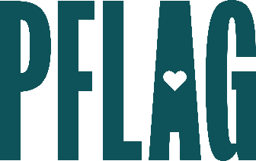 | Exclusive LGBTQ+ Legislative Issue Briefings

Session Description:
Many organizations are looking for ways to educate leadership and employees about what local, state and federal laws that impact the LGBTQ+ community mean for business and inclusion. PFLAG National—a nonpartisan organization—offers one-hour, workplace-appropriate issue overview briefings. Using PFLAG’s inclusive, diverse, and education focused approach, this session provides unique and timely learning opportunities for participants. Please note: Content for these briefings is dependent on current issues/events.

Starter questions:
- Where can I learn more about what’s happening in my state and about ways to get more involved locally?
- Do you have any recommendations for getting [COMPANY] to take a (stronger) stance on anti-LGBTQ+ legislation being introduced in states where we have employees?
- What do you think the outlook for the Equality Act is right now? Is there anything else happening at the federal level that we should be paying attention to?

