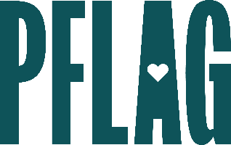
Below is starter language for your learning session invitation. Feel free to personalize as needed to make it engaging for your audience! Need logos? Check out PFLAG’s brand guide and access logo downloads online.
Re-Envisioning Pride, Inclusion, and Progress: Finding Signs of Hope and Action in Tough Times
The past few years have left many of people feeling unsure about how to move forward, what they should do next, and how to stay safe while focused LGBTQ+ equality.
In this session, participants will focus on learning about the past, understanding the present, and clearly defining action items for positive change. Sponsored by [ERG/ORG NAME] and presented by Straight for Equality (a program of PFLAG National) you’ll have a chance to:
- Understand where we are now in terms of progress, pride, and possibility by examining three major events that dominated the headlines in recent years:
  - COVID-19: At the start, it was compared to the emergence of HIV and AIDS. But is the parallel fair and accurate? And what lessons can we learn from our history of activism?
  - Racial Justice Work: The Black Lives Matter movement redefined what civic engagement can look like. How did the movement to affirm and celebrate black lives model what truly intersectional work can look like? How can LGBTQ+ advocates use it to fuel our own inclusive approach to change?
  - Global LGBTQ+ Change: There are many places across the globe – including some states in the US – where we are seeing unprecedented attacks on people who are LGBTQ+. What are we learning, and how can we remain part of creating change? What can we do to stay safe and avoid burnout?
- Identify signals of hope and progress that can help refocus our diversity, equity, and inclusion efforts and thrive as perfectly imperfect allies
We’ll also reserve plenty of time for Q&A!

Event Details:
Date + Time
Location
Contact Person
Additional information (e.g. lunch is provided, please RSVP, etc.)

