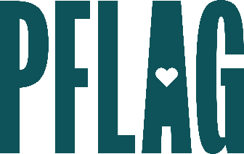 | Re-Envisioning Pride: Finding Signs of Hope and Action in Tough Times

Session Description:
Change in moments of social and political turmoil can be difficult, even for the most seasoned ally. In this session, we’ll look at the challenges of allyship in tumultuous times. We’ll also discuss the signals of hope and progress that can help refocus efforts while looking at behavioral shifts that help people weather hard times, push through barriers to inclusion, and thrive as perfectly imperfect allies.

Starter questions:
- It just feels like so much – what do you to avoid burnout and fatigue?
- What can we do to support LGBTQ+ young people who are being negatively impacted by what they’re seeing on the news every day?
- You mentioned looking for the silver lining – what is one thing that is giving you hope right now?

