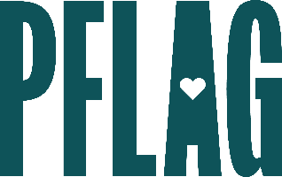
Below is starter language for your learning session invitation. Feel free to personalize as needed to make it engaging for your audience! Need logos? Check out PFLAG’s brand guide and access logo downloads online.
Be Kind, Rewind: Recognizing Your Role in Building Inclusion
Nearly everyone strives to be a more inclusive, kind team member, but getting it right is rarely easy. We are all products of our upbringing, environments, (un)conscious biases, and daily stressors. And while we may intend on being welcoming and inclusive, the impact of our actions may not be.
In this learning session participants will focus on learning from the past, understanding the present, and clearly defining action items that will create positive change in the future. Sponsored by [ERG/ORG NAME] and presented by Straight for Equality (a program of PFLAG National) you’ll have a chance to:
- Learn new ways to build awareness about your behavior and the effect it may have on others;
- Identify common places where (often unconscious) biases and assumptions can lead to strained or broken relationships at work;
- Discuss strategies – for individuals and organizations – for doing better as we move forward; and
- Get access to resources to work toward building welcoming, inclusive, and kind environments.
We’ll also reserve plenty of time for Q&A!

Event Details:
Date + Time
Location
Contact Person
Additional information (e.g. lunch is provided, please RSVP, etc.)

