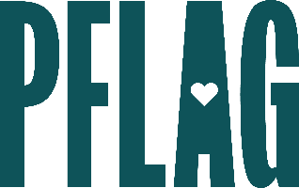
Below is starter language for your learning session invitation. Feel free to personalize as needed to make it engaging for your audience! Need logos? Check out PFLAG’s brand guide and access logo downloads online.
Thinking Strategically: Developing (and Growing) Your Ally Strategy
Engaging allies in diversity and inclusion work – in real and meaningful ways that keeps them coming back for more – is often easier said than effectively done.
Network group leaders and advocates are invited to participate in a dialogue about how they can develop and fine-tune ally engagement strategies and create programs that are focused, intersectional, and effective. Sponsored by [ERG/ORG NAME] and presented by Straight for Equality (a program of PFLAG National) you’ll have a chance to:
- Learn more about how PFLAG developed its ally engagement strategy based on decades of experience working with families and their loved ones who identify as LGBTQ+;
- Consider how ally engagement efforts have changed in recent years and what it means for engaging new and potential allies;
- Think about our individual and organizational expectations of allies and the role they should play in creating more inclusive and welcoming workplaces; and
- Get resources that can be used to ensure ally engagement programs serve employees, meet company goals, and help us to connect with one another.
All participants will receive access to amazing, easy to access, online resources to encourage continued learning!
Event Details:
Date + Time
Location
Contact Person
Additional information (e.g. lunch is provided, please RSVP, etc.)

