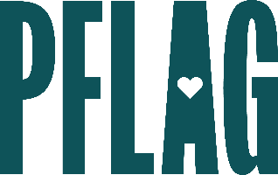
Below is starter language for your learning session invitation. Feel free to personalize as needed to make it engaging for your audience! Need logos? Check out PFLAG’s brand guide and access logo downloads online.
Advanced Bi+ Allyship: Going beyond the “Bi”nary
Beginning the bisexual+ (bi+) ally journey can take a lot of introspection about our unconscious biases. In this learning session for advanced allies, participants will learn some common myths and stereotypes about people who are bi+, discuss advanced bi+ ally behaviors, and continue the conversation about how organizations can grow to be even more inclusive of colleagues who are bi+.
Join this engaging and interactive learning session to learn about these topics and more! Sponsored by [ERG/ORG NAME] and presented by Straight for Equality (a program of PFLAG National) you’ll have a chance to:
- Review bi+ terminology and some of the challenges that people who are bi+ face;
- Unpack common myths and stereotypes about people who are bi+, how to push back when they come up, and ways to move beyond them;
- Consider advanced ally behaviors to continue your journey towards being a bi+ super ally;
- Suggest next steps that organizations can take to ensure that people who are bi+ feel included; and
- Connect with organizations led by, and resources created for, individuals with bi+ identities
We will also reserve time for Q&A so bring your questions!

Event Details:
Date + Time
Location
Contact Person
Additional information (e.g. lunch is provided, please RSVP, etc.)

