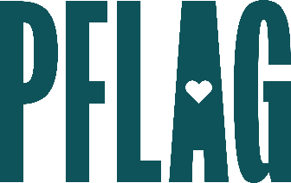 | Want to Be an Ally (Or Help One Out?): Building the Path for Your Ally Journey

Session Description:
Roughly half of LGBTQ+ adults remain closeted at work. In this session, participants (whether LGBTQ+ or not) will find out why that matters and the impact it has on the bottom line for organizations. They’ll learn the power allies have to create change. We’ll also provide space to honestly discuss the barriers to expressing support in the workplace. Finally, participants will get strategies and tools needed to be part of creating real inclusion.

Starter questions:
- Do you have any guidance for creating conversations about LGBTQ+ equality with children in my life?
- Can you tell me more about inclusive pronouns? Where did that conversation even come from?
- Do you have any specific recommendations for people managers?
- Could you give an example (or two) that allies could create teaching moments at work?

