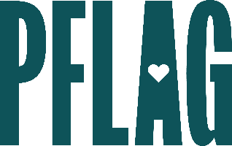
Below is starter language for your learning session invitation. Feel free to personalize as needed to make it engaging for your audience! Need logos? Check out PFLAG’s brand guide and access logo downloads online.
Bi+ 101 Allyship: How to Not Let Things Fall Bi the Wayside
There is still an unfortunate lack of representation and understanding of the bisexual+ (bi+) community. Many of us need to learn more about the largest identity group within the LGBTQ+ community – people who can form attraction to more than one gender.
Join this engaging and interactive learning session to learn more! Sponsored by [ERG/ORG NAME] and presented by Straight for Equality (a program of PFLAG National) you’ll have a chance to:
- Review terminology around sexual and romantic orientation, gender identity and expression;
- Learn about some of the identities and labels that people who can form attraction to more than one gender may use to describe themselves (e.g. bisexual, pansexual, fluid, queer);
- Consider data and research about the bi+ community and the disparities that people who are bi+ often face, even in LGBTQ+ spaces; and
- Discuss questions to ask yourself on your journey to being a better bi+ all, and identify inclusive resources to continue your learning;
We will also reserve time for Q&A so bring your questions!

Event Details:
Date + Time
Location
Contact Person
Additional information (e.g. lunch is provided, please RSVP, etc.)

