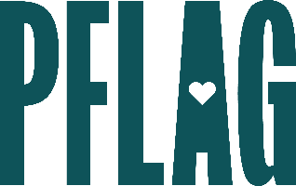
Below is starter language for your learning session invitation. Feel free to personalize as needed to make it engaging for your audience! Need logos? Check out PFLAG’s brand guide and access logo downloads online.
When Someone Comes Out: Demonstrating Support and Acceptance
The term “coming out” has become so mainstream that many people assume that the word—and the actions it entails—are simple. However, in spite of the increase in acceptance for people who identify as LGBTQ+, the process can still be nerve-wracking, especially at work.
You’re invited to learn more about the positive impact that living authentically, feeling supported, and celebrating one’s identity has on people who are LGBTQ+. Sponsored by [ERG/ORG NAME] and presented by Straight for Equality (a program of PFLAG National) you’ll have a chance to:
- Review LGBTQ+ terminology related to coming out, inviting in, and disclosure;
- Learn about some of the positive impacts that living authentically can have for people who are LGBTQ+;
- Get guidance on what to think about and questions to consider if you’re planning on coming out;
- Consider ways that you can demonstrate support and celebrate your friends, colleagues, and family who have recently come out as LGBTQ+; and
- Connect with resources from PFLAG National and partner organizations to learn more
All participants will receive access to Our Children (in both English and Spanish) from PFLAG National as a great takeaway resource!
Event Details:
Date + Time
Location
Contact Person
Additional information (e.g. lunch is provided, please RSVP, etc.)

