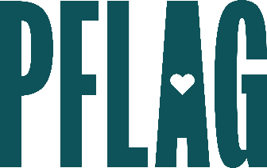 | Employee Resource Groups Give Back: Engaging Leaders and Activating Volunteers

Session Description:
As employee resource groups (ERGs) grow and evolve, they often strive to establish themselves as a valued part of company culture. Relying on PFLAG National’s experience working with grassroots organizers and volunteers, this session will help ERG leaders create inclusive internal and external volunteer opportunities, manage barriers that may keep employees from getting involved, and leverage the strengths of employees who would like to engage more.

Starter questions:
- What can [COMPANY] do to directly connect with local PFLAG chapters?
- Our network group has a really small budget – Do you have any recommendations for covering some of the costs associated with DIY volunteer projects?
- We’re starting to hear that potential volunteers are concerned about their safety at LGBTQ+ events – do you have any recommendations to alleviate those fears?

