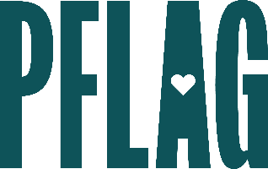
Below is starter language for your learning session invitation. Feel free to personalize as needed to make it engaging for your audience! Need logos? Check out PFLAG’s brand guide and access logo downloads online.
Don’t Know Much About LGBTQ+ History? The Ultimate LGBTQ+ History and Culture Extravaganza
In most states, LGBTQ+ history and the contributions of LGBTQ+ people are not acknowledged in the classroom. And books about LGBTQ+ history and culture are being removed from libraries shelves across the country. What does it mean when LGBTQ+ people can’t see themselves in our shared history?
You’re invited to participate in a learning session that will help you learn more about the vibrant, diverse, and determined LGBTQ+ community throughout history. Sponsored by [ERG NAME} and presented by Straight for Equality (a program of PFLAG National) you’ll have a chance to:
- Investigate how far back in our shared history LGBTQ+ organizing and advocacy goes;
- Learn more about some of the people, places, signs, and symbols that are commonly associated with LGBTQ+ culture in the US;
- Have some fun as we discuss the long-term and ongoing influence the LGBTQ+ community has had, and continues to have, on popular culture; and
- Get some great insight into how the larger story about LGBTQ+ history and culture impact the conversations about diversity, equity, inclusion, and access in the workplace today.
All participants will receive access to amazing, easy to access, online resources to encourage continued learning!
Event Details:
Date + Time
Location
Contact Person
Additional information (e.g. lunch is provided, please RSVP, etc.)

