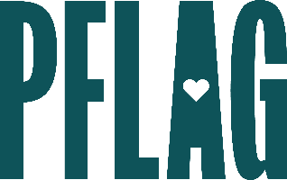
Below is starter language for your learning session invitation. Feel free to personalize as needed to make it engaging for your audience! Need logos? Check out PFLAG’s brand guide and access logo downloads online.
Be Kind, Not Just Nice: Transforming Your Conversations
We all know the phrase "if you're not going to say something nice, then don't say anything at all." But what do we do when others don't follow that rule? What about when unkindness impacts people and communities we care about, including our LGBTQ+ loved ones? What do we do when being kind means speaking up and not being so nice?
You’re invited to join us to answer those questions and more. Sponsored by [ERG/ORG NAME] and presented by Straight for Equality (a program of PFLAG National) you’ll have a chance to:
- Review the strategies from “Be Kind, Rewind: Recognizing Your Role in Building Inclusion” to help us stay mindful and kind when conflict arises;
- Consider various scenarios to develop the skills we need to deal with unkindness without becoming unkind ourselves;
- Identify methods to determine when something is being said or someone is asking questions in good faith or bad faith;
- Frame our strategies to be used in different aspects of our lives including with friends and family, at work, and in online spaces; and
- Get resources to help inform your kindness strategies into the future.
We’ll also reserve plenty of time for Q&A!
Event Details:
Date + Time
Location
Contact Person
Additional information (e.g. lunch is provided, please RSVP, etc.)

