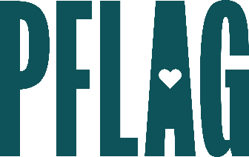 | Be Kind, Not Just Nice: Transforming Your Conversations

Session Description:
We all know the phrase "if you're not going to say something nice, then don't say anything at all." But what do we do when others don't follow that rule? What about when unkindness impacts people and communities we care about, including our LGBTQ+ loved ones? What do we do when being kind means speaking up and not being so nice? Join the PFLAG National team to learn some of the skills you need to transform your conversations and stand by what you believe in without becoming unkind yourself.

Starter questions:
- In these difficult conversations – even those that are clearly in good faith – how do you manage frustration and burnout?
- Do you have any recommendations for getting out of bad faith arguments gracefully and in a way that doesn’t let the other person feel like they’ve “won”?
- I just don’t have it in me to do online arguments anymore – are there still ways I can let my networks know where I stand and correct misinformation online?

