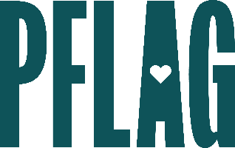
Below is starter language for your learning session invitation. Feel free to personalize as needed to make it engaging for your audience! Need logos? Check out PFLAG’s brand guide and access logo downloads online.
When LGBTQ+ Past and Present Collide! How LGBTQ+ History Can Illuminate Today’s Challenges
Understanding the facts, correcting misinformation, and considering how LGBTQ+ history shapes the world we’re in today are all essential parts of creating change in our communities.
You’re invited to participate in a fast-paced learning session that will help you better understand LGBTQ+ history and how it can inform your advocacy in 2024 and beyond. You’ll also learn how to use this knowledge to become better allies and create conversations about LGBTQ+ equality in various aspects of your life. Sponsored by [ERG/ORG NAME] and presented by Straight for Equality (a program of PFLAG National) you’ll have a chance to:
- Expand upon key learnings from Straight for Equality’s “Don't Know Much About LGBTQ+ History? The Ultimate LGBTQ+ History and Culture Extravaganza” learning session;
- Tie current high-profile issues, including local and state bills targeting transgender youth and the fight to pass the Equality Act, to LGBTQ+ history;
- Highlight the strategies, tools, and lessons from the past that you can use to inform the advocacy work you are doing in your community today; and
- Learn more about key LGBTQ+ historic figures and their advocacy style to help individuals find inspiration and guidance for their own advocacy efforts.
Event Details:
Date + Time
Location
Contact Person
Additional information (e.g. lunch is provided, please RSVP, etc.)

