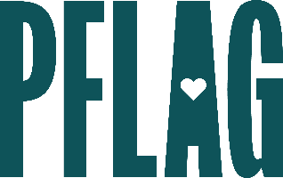
Below is starter language for your learning session invitation. Feel free to personalize as needed to make it engaging for your audience! Need logos? Check out PFLAG’s brand guide and access logo downloads online.
Sharing Your Workplace Story to Create Change
Personal stories about the impact of diversity, equity, inclusion, and access efforts (or the lack thereof) can be memorable, powerful, and motivational. When people tell their stories about LGBTQ+ equality, they have the power to help others re-examine their own perceptions about an issue or situation.
You’re invited to participate in a highly interactive learning session that will help you develop your personal story about why you are or why you need an ally, to help to create a more inclusive workplace. Sponsored by [ERG/ORG NAME] and presented by Straight for Equality (a program of PFLAG National) you’ll have a chance to:
- Learn more about the many ways our personal stories can transform the way people see each other, their differences, and their similarities;
- Review some basic tips for developing an effective storytelling style for one-on-one conversations as well as for public speaking engagements;
- Access tools, resources, and materials that will help you grow your confidence if the idea of sharing your story makes you nervous; and
- Create and share your two-minute story using the story arc model and get feedback from other participants (optional, but encouraged!)

Event Details:
Date + Time
Location
Contact Person
Additional information (e.g. lunch is provided, please RSVP, etc.)

