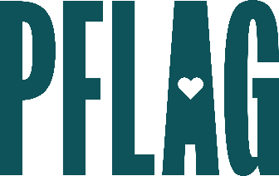 | Sharing Your Workplace Story  to Create Change

Session Description:
PFLAG National believes that when we share our personal stories, we transform the conversation about LGBTQ+ equality. And while everyone has a story to tell we’re rarely taught to share our stories effectively. In this learning session participants will identify and develop their workplace stories about LGBTQ+ inclusion. They’ll also have an opportunity to share their stories and receive peer feedback in a supportive environment. Session materials include a customized storytelling workbook.

Starter questions:
- Can you tell us a little more about what you mean about insider language? If I have to define everything, that could take up all the time I have to share my story!
- What do you do when someone says that they don’t have a story to tell?
- Do you have any recommendations for parents/families/allies that want to share their story publicly but are concerned about their LGBTQ+ loved one’s safety?
- How can we create a campaign for LGBTQ+ people and allies to share their stories here at [COMPANY]?

