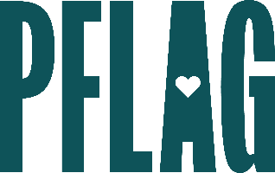
Below is starter language for your learning session invitation. Feel free to personalize as needed to make it engaging for your audience! Need logos? Check out PFLAG’s brand guide and access logo downloads online.
What the Plus?: Understanding and Supporting Expansive LGBTQ+ Identities
Lesbian. Gay. Bisexual. Transgender. Queer. Simple, right?
Not for everyone. As conversations about sexual orientation, gender identity, and gender expression evolve, employees feel empowered to own less commonly understood identities. Often, this creates challenges for companies who strive to create welcoming and inclusive workplace culture. Knowing how to support employees and how to demonstrate allyship is a necessary part of diversity, equity, inclusion, and access efforts for corporations.
Join this engaging and interactive learning session to continue your learning journey! Sponsored by [ERG/ORG NAME] and presented by Straight for Equality (a program of PFLAG National) you’ll have a chance to:
- Review some of the identities that are often considered to be a part of “the plus” including nonbinary, Two-Spirit, bisexual, pansexual, asexual, aromantic, and intersex;
- Discuss ways to demonstrate allyship to individuals who hold these, sometimes invisible, identities;
- Consider ways to develop effective [ERG/ORG] programming focused on these, often underserved, identities, and;
- Get connected with organizations led by, and resources created for, individuals and communities with identities that are a part of “the plus”.
We’ll also reserve plenty of time for Q&A!
Event Details:
Date + Time
Location
Contact Person
Additional information (e.g. lunch is provided, please RSVP, etc.)

