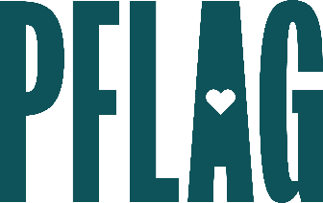 | What the Plus?: Understanding and Supporting Expansive LGBTQ+ Identities

Session Description:
Lesbian. Gay. Bisexual. Transgender. Queer. Simple, right? Not for everyone. In this session, we’ll spend time discussing what the + after “LGBTQ+” encompasses. Participants will have the opportunity to learn more about nonbinary gender identities, bisexual+ identities, asexuality and aromanticism, and intersex experiences. No matter how you identify, this session will help you serve as an ally to others in this space.

Starter questions:
- How could someone’s sexual orientation and romantic orientation possibly be different?
- There are so many words to keep up with – how can I stay up to date, make sure I’m getting things right, and ensure that I’m not unintentionally offending people?
- If your identity can shift and change over time – how is that different from choosing your sexual orientation and/or gender identity?

