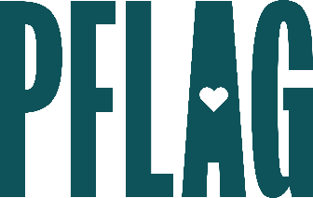 | What Would You Do?: A Guide to Being an Active Ally in Tough Situations

Session Description:
This session for advanced, self-identified allies leads participants in a skill-building experience to fine-tune their allyship and develop the resources needed to take on the tough and tricky world of difficult situations. This customized, scenario-based session features opportunities for participants to apply what they’ve learned to real-world situations and share their unique strategies for transforming from good to great allies in the workplace.

Starter questions:
- Do you have any additional recommendations for having conversations with people whose primary pushback has to do with their religious beliefs?
- How can people take the skills that we talked about today to demonstrate their allyship to other marginalized communities?
- Are there ways that people can get more involved with PFLAG? What about other LGBTQ+ organizations

