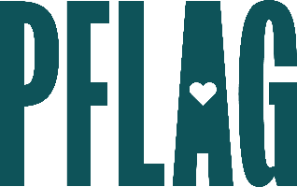
You can find helpful language to start the invitation for your learning session below. Feel free to personalize as needed to make it engaging for your audience! Need logos? Check out PFLAG’s brand guide and access logo downloads online.
Celebrate and Affirm: Being a Supportive Parent and Caregiver
Being a caregiver is hard. There is so much to keep up with. And things can become more complicated when you’re learning how to support a young person who is LGBTQ+. Taking the time to learn terminology and language as well as strategies to help you get it right are amazing steps to take to be a parent or caregiver who truly leads with love. It will help you discover opportunities to shift from passive acceptance to celebration and affirmation which can make a world of difference in the lives of LGBTQ+ young people.
You’re invited to talk about the power that parents/caregivers can have in supporting their LGBTQ+ loved ones. Sponsored by [ERG/ORG NAME] and presented by Straight for Equality (a program of PFLAG National) you’ll have a chance to:
- Review the importance of being an ally and the vital (and life-saving) role that parent and caregiver support can play for LGBTQ+ young people;
- Share key terminology and vocabulary used by LGBTQ+ youth to describe their identity, including words that are less commonly understood;
- Unpack some common concerns that parents and caregivers have for their LGBTQ+ children and consider advice for moving past them when concern becomes a barrier to active support; and
- Discuss helpful ally behaviors including how to apologize effectively, correct others, and advocate for change in order to show active support and love to LGBTQ+ youth.
All participants will receive access to PFLAG National and Straight for Equality resources to support their continued learning.
Event Details:
Date + Time
Location
Contact Person
Additional information (e.g. lunch is provided, please RSVP, etc.)

