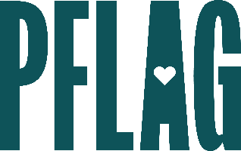

**Below is starter language for your ally training invitation. Feel free to personalize as needed to make it engaging for your audience! Need logos? Check out** [**PFLAG’s brand guide**](https://pflag.org/wp-content/uploads/2023/01/PFLAG_National_BrandGuide_2023.pdf) **and access** [**logo downloads**](https://pflag.org/our-brand/) **online.**

**Fight Your Fears: Developing Advanced Ally Skills**

Even the most well-intentioned and dedicated allies have questions about how to be more inclusive of people who are LGBTQ+ at work and in their personal lives. Questions like: Should I self-identify as an ally? How do I create conversations about LGBTQ+ equality without making it “political?” Where can I learn more about basic terminology and using pronouns in an affirmative way? How can I manage conflict that leaves me feeling like I want to be less visible and vocal as an ally?

In this session, you’ll learn how to grow your ally skills, no matter how you identify, on your journey to super-ally status. Sponsored by [ERG/ORG] and presented by Straight for Equality (a program of PFLAG National), during this learning session, you’ll have a chance to:

* Understand more about PFLAG’s Straight for Equality program, ways to recognize the ally potential in everyone, and the power that allies have to create meaningful change;
* Review the basics that all allies need to understand, like terminology and effectively using expansive pronouns, to establish yourself as an ally who is willing to do the work
* Discuss common challenges that many allies face AND learn strategies to overcome them; and
* Find out more about the resources available at [**ORGANIZATION]** that will help you be a more powerful ally for LGBTQ+ equality.

All participants will receive access to PFLAG National and Straight for Equality resources to support their continued learning.

Event Details:

Date + Time

Location

Contact Person

Additional information (e.g. lunch is provided, please RSVP, etc.)