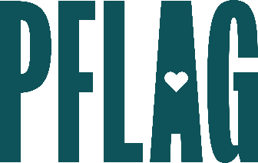 | Fight Your Fears:  Developing Advanced Ally Skills

Session Description:
When allies face challenges to demonstrating support for the LGBTQ+ community, we may become less visible and vocal. In this session, participants will find out how to transform the reason they’re an ally (or need one) into action, get effective strategies to create conversation about LGBTQ+ equality, and understand how to transform conflict into opportunity.

Starter questions:
- Can you give an example of how you’d create a conversation about LGBTQ+ equality with a group people?
- In your opinion, would a cishet ally sharing their pronouns and using words like partner and spouse ever be considered appropriation?
- You mentioned assuming non-harmful intent – do you have any recommendations for those times you really, truly believe someone’s intent is to be harmful?

