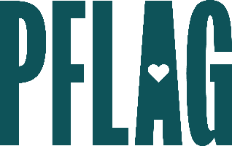
You can find helpful language to start the invitation for your learning session below. Feel free to personalize as needed to make it engaging for your audience! Need logos? Check out PFLAG’s brand guide and access logo downloads online.
So What’s Next? Developing Advanced Ally Skills
Even the most well-intentioned and dedicated allies have questions about how to be more visible, vocal, and supportive of the LGBTQ+ people in their lives. Questions like: Should I self-identify as an ally? How do I create conversations about LGBTQ+ equality without making it “controversial?” How can I manage conflict that leaves me feeling too nervous to push back against anti-LGBTQ+ language or misinformation?
In this session, you’ll learn how to further develop your ally skills, no matter how you identify. Sponsored by [ERG/ORG] and presented by Straight for Equality (a program of PFLAG National), during this learning session, you’ll have a chance to:
- Review the basics that all allies need to understand, like terminology and effectively using expansive pronouns, to establish yourself as an ally who is willing to do the work;
- Understand how to recognize the ally potential in everyone, and the power that allies have to create meaningful change;
- Discuss common challenges that many allies face AND learn strategies to overcome them; and
- Find out more about the resources available at [ORGANIZATION] that will help you be a more powerful ally for LGBTQ+ equality.
All participants will receive access to PFLAG National and Straight for Equality resources to support their continued learning.
Event Details:
Date + Time
Location
Contact Person
Additional information (e.g. lunch is provided, please RSVP, etc.)

