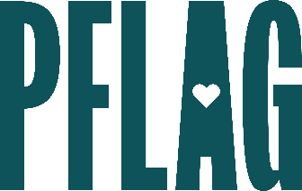 | Advanced Bi+ Allyship: Going Beyond  the “Bi”nary

Session Description:
Have you ever heard unkind things about people who are attracted to multiple genders and you weren’t quite sure if you should believe it or how to correct it? In this learning session for advanced allies, participants will learn some common myths and stereotypes about people who are bi+, discuss advanced bi+ ally behaviors, and continue the conversation about how organizations can grow to be even more inclusive of people who are bi+.

Starter questions:
- Where do you think the most common myths and stereotypes about bi+ people come from?
- Are there any examples of popular media right now that you think are really doing bi+ representation well?
- Do you have any recommendations for conversations with people who assert that identifying as bisexual excludes trans and non-binary people?

- How can we have conversations about bi+ representation in a moment when it feels like other marginalized groups are being targeted more aggressively?

- What “red flags” should I look out for among my bi+ friends so I can offer support as needed?

