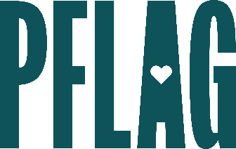 | Bi+ Allyship: How to Not Let Things Fall Bi the Wayside

Session Description:
There is still an unfortunate lack of representation and understanding of the bisexual+ (bi+) community. Many of us need to not only learn more about the largest identity group within the LGBTQ+ community, we also need to dispel common myths and stereotypes we’ve been taught about people who can form attraction to more than one gender.

Starter questions:
- I’ve never heard the term bi+ before. Where did this term originate and why is it used?
- What is the actual difference between words like bi+, pan, and others?
- Why do you think people who are bi+ are out at such significantly lower rates than gay and lesbian folks?
- It seems like a lot of young people identify as bi+. Could it be that they’re just trying to fit in or be trendy?
- Can you give some examples of what biphobia might look like in day-to-day life? What about bi+ erasure?

