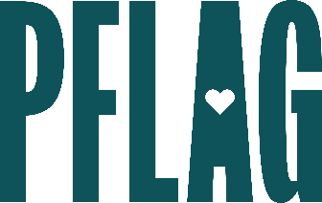 | Want to be a Trans and Nonbinary Ally? Expand Your Ally Journey Beyond the Binary

Session Description:
Visibility for people who are transgender (trans) and nonbinary has increased dramatically in the US in recent years. But what we see on the news and in popular entertainment doesn’t always provide the background and context we need to understand what gender identity and expression really mean, what people who are trans and nonbinary experience, why personal pronouns matter, or what role allies can play in these complicated times.

Starter questions:
- I keep seeing reports that more young people than ever now identify as trans or nonbinary. What’s going on with that?
- Can you explain the difference between nonbinary and gender non-conforming? Is there a difference?
- Do you have any thoughts on gendered colloquialisms like “you guys” and “dude?” Do you have any alternatives that you would suggest when addressing a group?
- Where I live – using sir and ma’am is expected and a way to demonstrate respect. Is there an accepted gender inclusive alternative? What would you recommend if I’m not sure how someone identifies?
- What can I do to be a better advocate for transgender and nonbinary youth in my state?

