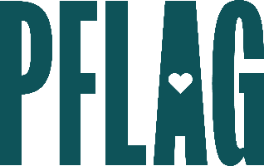
You can find helpful language to start the invitation for your learning session below. Feel free to personalize as needed to make it engaging for your audience! Need logos? Check out PFLAG’s brand guide and access logo downloads online.
What the Plus?: Understanding and Supporting Expansive LGBTQ+ Identities
As conversations about sexual orientation, gender identity, and gender expression evolve, employees may feel empowered to own identities that go beyond lesbian, gay, bisexual, transgender, and queer. This can create challenges for companies who strive to create welcoming workplace culture because many people know far less about identities that commonly make up “the plus.”
Join this engaging and interactive learning session to continue your learning journey! Sponsored by [ERG/ORG NAME] and presented by Straight for Equality (a program of PFLAG National) you’ll have a chance to:
- Review some of the identities that are often considered to be a part of “the plus” including intersex, nonbinary, Two-Spirit, bisexual, pansexual, asexual, and aromantic;
- Discuss ways to demonstrate allyship to individuals who hold these less well-known and sometimes-invisible identities;
- Consider ways to develop effective [ERG/ORG] programming focused on these, often underserved, identities, and;
- Get connected with organizations led by, and resources created for, individuals who hold identities that are commonly a part of “the plus”.
All participants will receive access to PFLAG National and Straight for Equality resources to support their continued learning.
Event Details:
Date + Time
Location
Contact Person
Additional information (e.g. lunch is provided, please RSVP, etc.)

