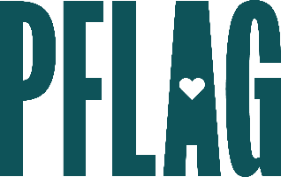
You can find helpful language to start the invitation for your learning session below. Feel free to personalize as needed to make it engaging for your audience! Need logos? Check out PFLAG’s brand guide and access logo downloads online.
What Would You Do? Being an Active Ally in Tough Situations
Knowing when, where, and how to react to anti-LGBTQ sentiments can be stressful, especially in the workplace. This session, developed for advanced, self-identified allies, takes on that issue and leads participants in a skill-building experience to fine-tune their ally skills and find the resources they need to take on a tough and tricky world.
Join [ERG NAME/ORG] for an engaging learning session with educators from Straight for Equality (a program of PFLAG National). During the session, you’ll have an opportunity to:
- Consider various steps to learn and grow that more advanced allies take to become better allies and stronger champions for LGBTQ+ equality;
- Develop skills to turn potential conflict into communication and understanding;
- Apply what you’ve learned to real-world, workplace focused scenarios and share your unique strategies as part of a group discussion; and
- Access resources, materials, recommendations, and more to help with your ally efforts.
All participants will receive access to PFLAG National and Straight for Equality resources to support their continued learning.
Event Details:
Date + Time
Location
Contact Person
Additional information (e.g. lunch is provided, please RSVP, etc.)

