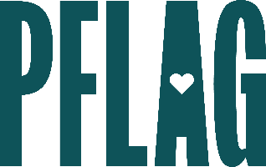

**Below is starter language for your learning session invitation. Feel free to personalize as needed to make it engaging for your audience! Need logos? Check out** [**PFLAG’s brand guide**](https://pflag.org/wp-content/uploads/2023/01/PFLAG_National_BrandGuide_2023.pdf) **and access** [**logo downloads**](https://pflag.org/our-brand/) **online.**

**Be Kind, Even When It’s Tough**

In tough times, having difficult conversations with our friends, family, colleagues, and community is more important than ever. But staying kind in the face of unkind behavior, bad faith arguments, and conflict is extremely difficult (for all of us). In this session, participants will solidify their skills in managing complex moments of tension while still treating others with kindness. We’ll discuss multiple nuanced real-world scenarios where kindness can be deeply transformative in this highly interactive learning session.

In this session we will:

* Consider various skills we must develop to maintain our composure and create kind conversations, even in moments of tension;
* Discuss some of the most common bad faith arguments you may hear when talking about LGBTQ+ equality - and simple ways to counter them;
* Engage in scenario-based learning to explore how we may personally respond in moments of conflict and find ways to grow together; and
* Get resources to help inform our kindness and safety strategies in the future.

We’ll also reserve plenty of time for Q&A!

Event Details:

Date + Time

Location

Contact Person

Additional information (e.g. lunch is provided, please RSVP, etc.)