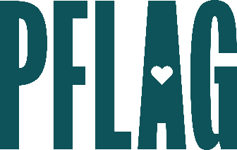 | Be Kind, Even When It’s Tough

Session Description:
In tough times, having difficult conversations with our friends, family, colleagues, and community is more important than ever. But staying kind in the face of unkind behavior, bad faith arguments, and conflict is extremely difficult (for all of us). In this session, participants will solidify their skills in managing complex moments of tension while still treating others with kindness. We’ll discuss multiple nuanced real-world scenarios where kindness can be deeply transformative in this highly interactive learning session.

Starter questions:
- Are there any bad faith arguments that you won’t ever engage with?
- What strategies can people develop to manage burnout when they feel that they are not moving the needle—or even if the needle is moving the other way?
- How can individuals support each other and provide unity in moments of conflict?
- How can I manage potentially unsafe behaviors and beliefs when the person espousing them is someone I can’t easily avoid (e.g., A family member, coworker, etc.)?

