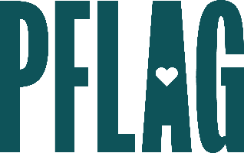
You can find helpful language to start the invitation for your learning session below. Feel free to personalize as needed to make it engaging for your audience! Need logos? Check out PFLAG’s brand guide and access logo downloads online.
Being an Asexual and Aromantic Ally: You Can't Fix What's Not Broken
Asexual and aromantic people are members of the LGBTQ+ community whose stories are often left unexplored. In this session, participants will learn more about people who are asexual and aromantic, how their experiences differ from those of allosexual and alloromantic people, and how we can all be better allies that create space that is not only inclusive, but also affirming. No matter how you identify, this session will help you serve as an active ally.
Join this engaging and interactive learning session to continue your learning journey! Sponsored by [ERG/ORG NAME] and presented by Straight for Equality (a program of PFLAG National) you’ll have a chance to:
- Review terminology related to sexual orientation, romantic orientation and other orientations that have to do with how we relate to others;

- Discuss the experiences of people who are asexual and/or aromantic in different areas of life;
- Name and then dispel common myths about people who are asexual and/or aromantic;

- Consider a variety of ways to show up as a stronger ally to people who are asexual and/or aromantic.
All participants will receive access to PFLAG National and Straight for Equality resources to support their continued learning.
Event Details:
Date + Time
Location
Contact Person
Additional information (e.g. lunch is provided, please RSVP, etc.)

