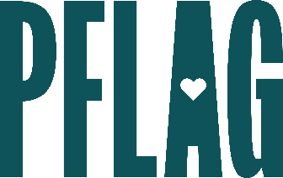 | Mutual Aid: Rethinking Volunteerism to Meet Community Needs

Session Description:
In times of crisis, communities often turn to mutual aid to meet needs that are not being met by existing systems. For example, in the LGBTQ+ community, mutual aid continues to be an integral part in the fight against HIV/AIDS. In this learning session participants will learn about mutual aid and how it differs from traditional charity work. They will also consider best practices for participating in mutual aid networks and things to keep in mind as they participate in this kind of community support. And while we encourage folks to become a part of existing networks, participants will also be guided through a step-by-step process to create a new mutual aid network, if it is needed.

Starter questions:
- A lot of what you describe as mutual aid sounds like just being a good neighbor. Why do people need to complicate something that is so simple?
- Where do the goods, resources, and money to establish a mutual aid project come from?

- A few of the mutual aid projects you highlighted seem like they are connected to specific events (e.g., a natural disaster) or like they are developed to address a very specific problem (e.g., a resource exchange because of benefits cuts). Are all mutual aid projects supposed to be time-limited?

- I’m interested in joining or starting a mutual aid network. Do you have any advice for avoiding hierarchical structures and staying rooted in solidarity?

